City: Paris

Season: Spring Summer

Women

Ready-to-Wear

Year: 2022

Brand Name: Amiri

Designer Name: Mike Amiri

Description: Amiri often showed menswear and womenswear together on its runways in Paris, with women in longline seafoam suiting and boxy leather jackets slotting almost anonymously into Mike Amiri’s men’s lineup. The pandemic and its related lockdowns gave him a moment to reconsider exactly who the Amiri woman is and what she’d want to wear. The 22 looks shown here, for spring 2022, are no longer the addendum to a cool dude parade, but their own sure-footed proposition for how women should dress.

[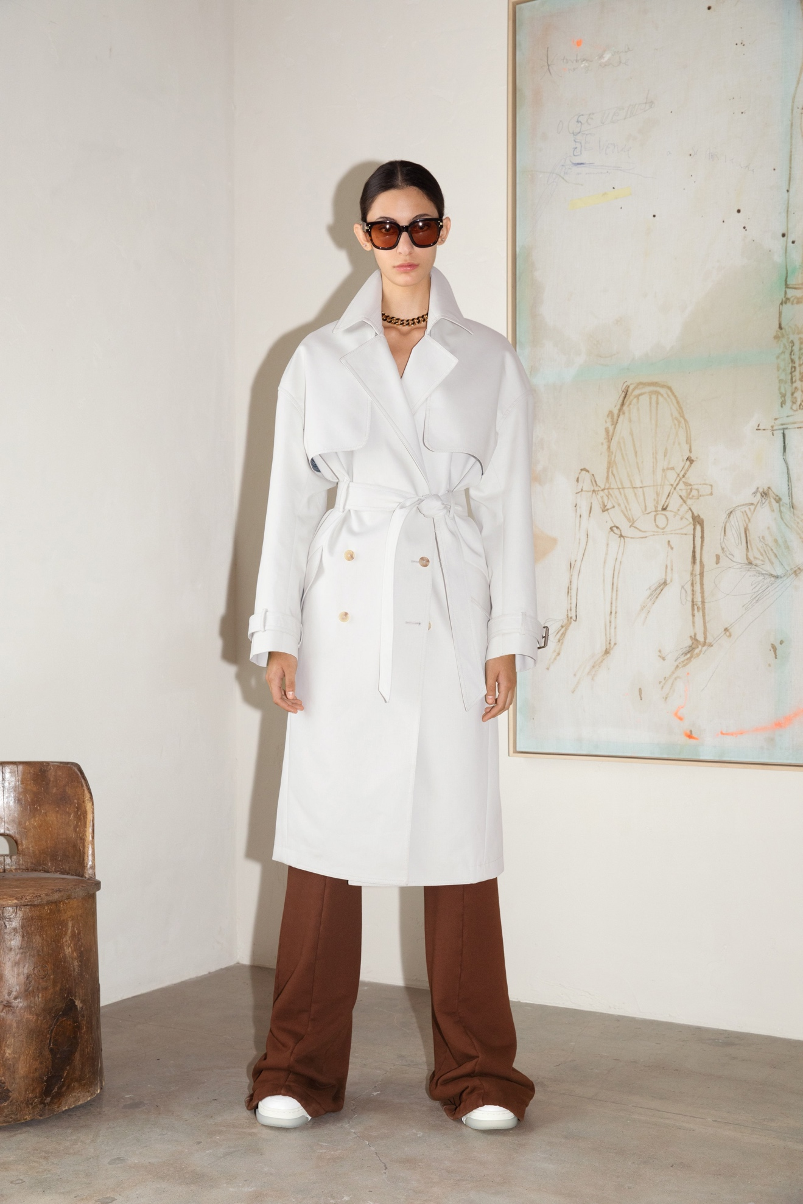Look 1](https://www.vogue.com/fashion-shows/spring-2022-ready-to-wear/amiri/slideshow/collection#1)[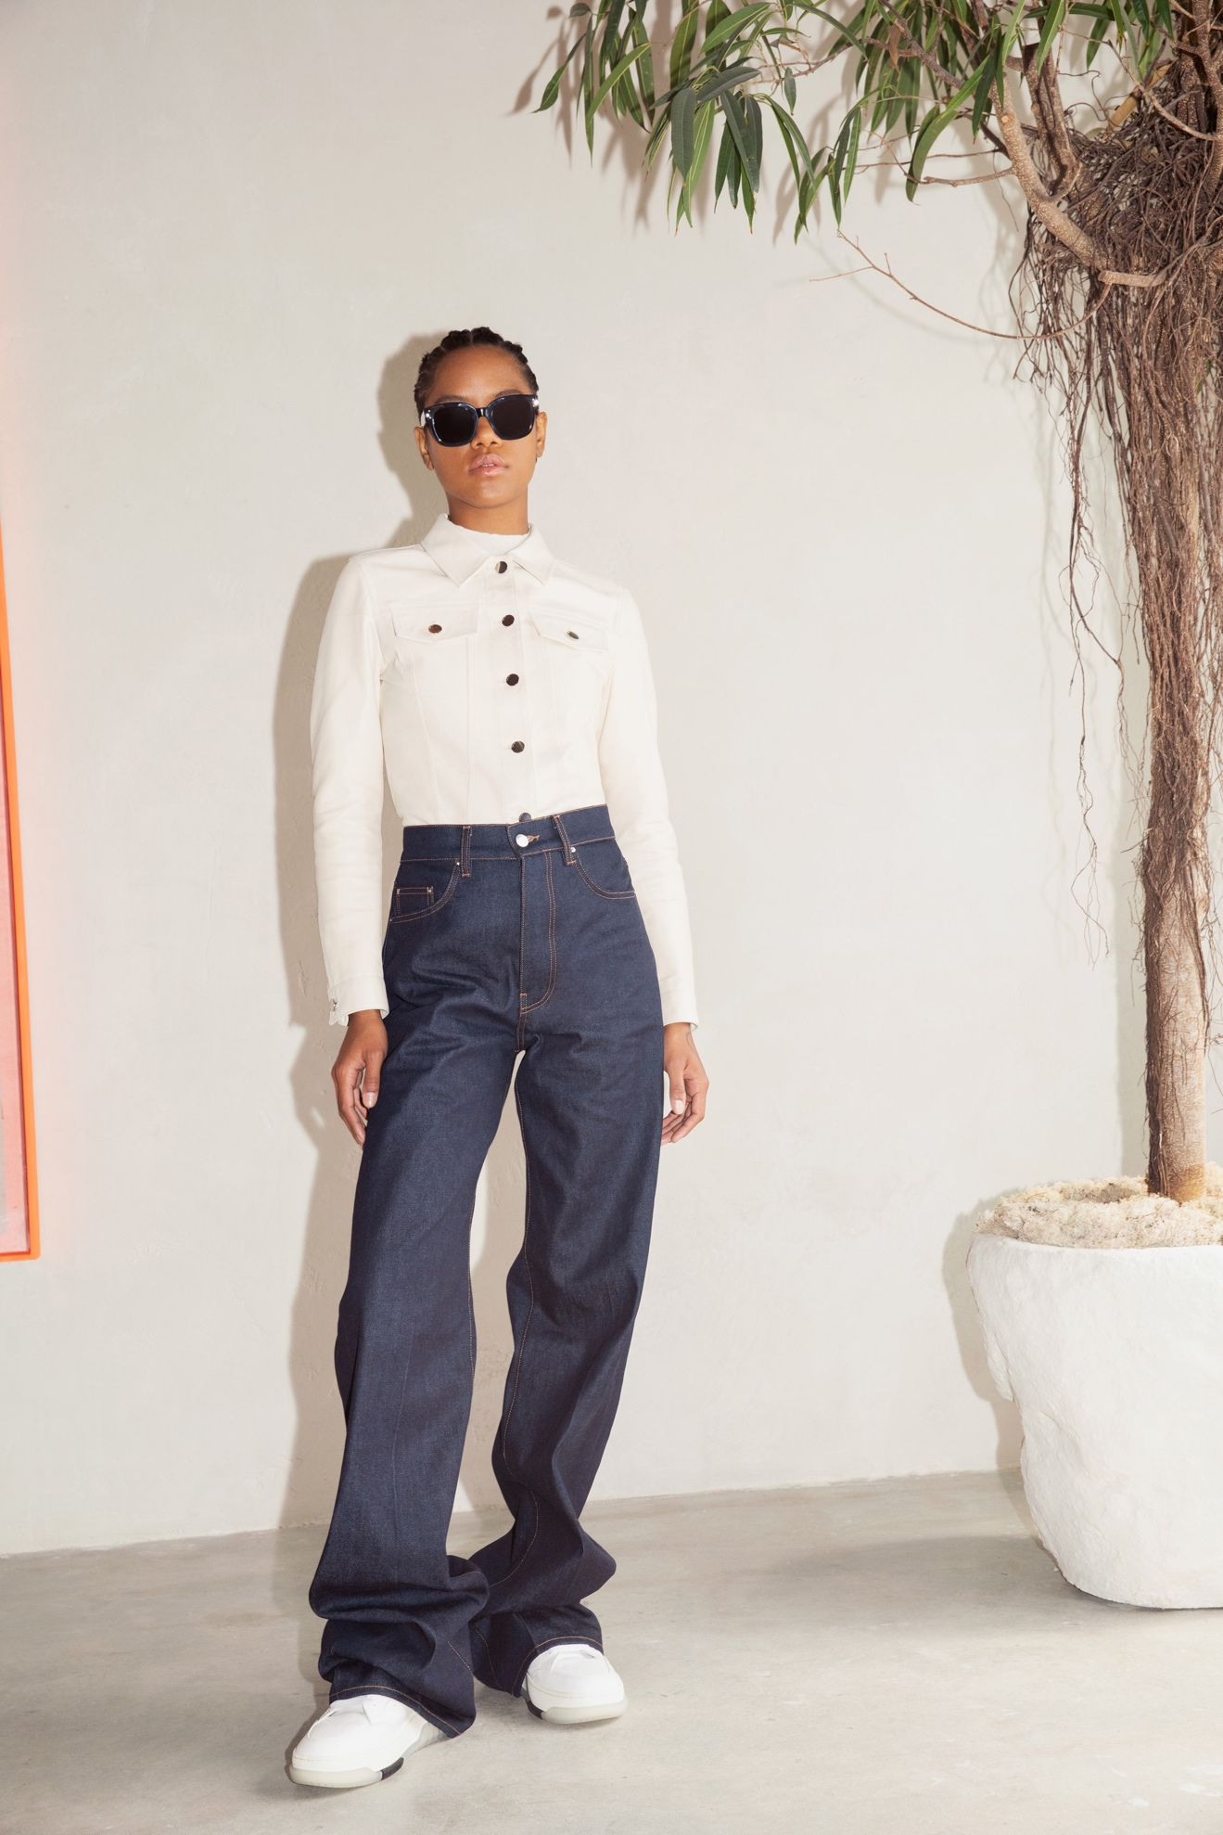Look 2](https://www.vogue.com/fashion-shows/spring-2022-ready-to-wear/amiri/slideshow/collection#2)[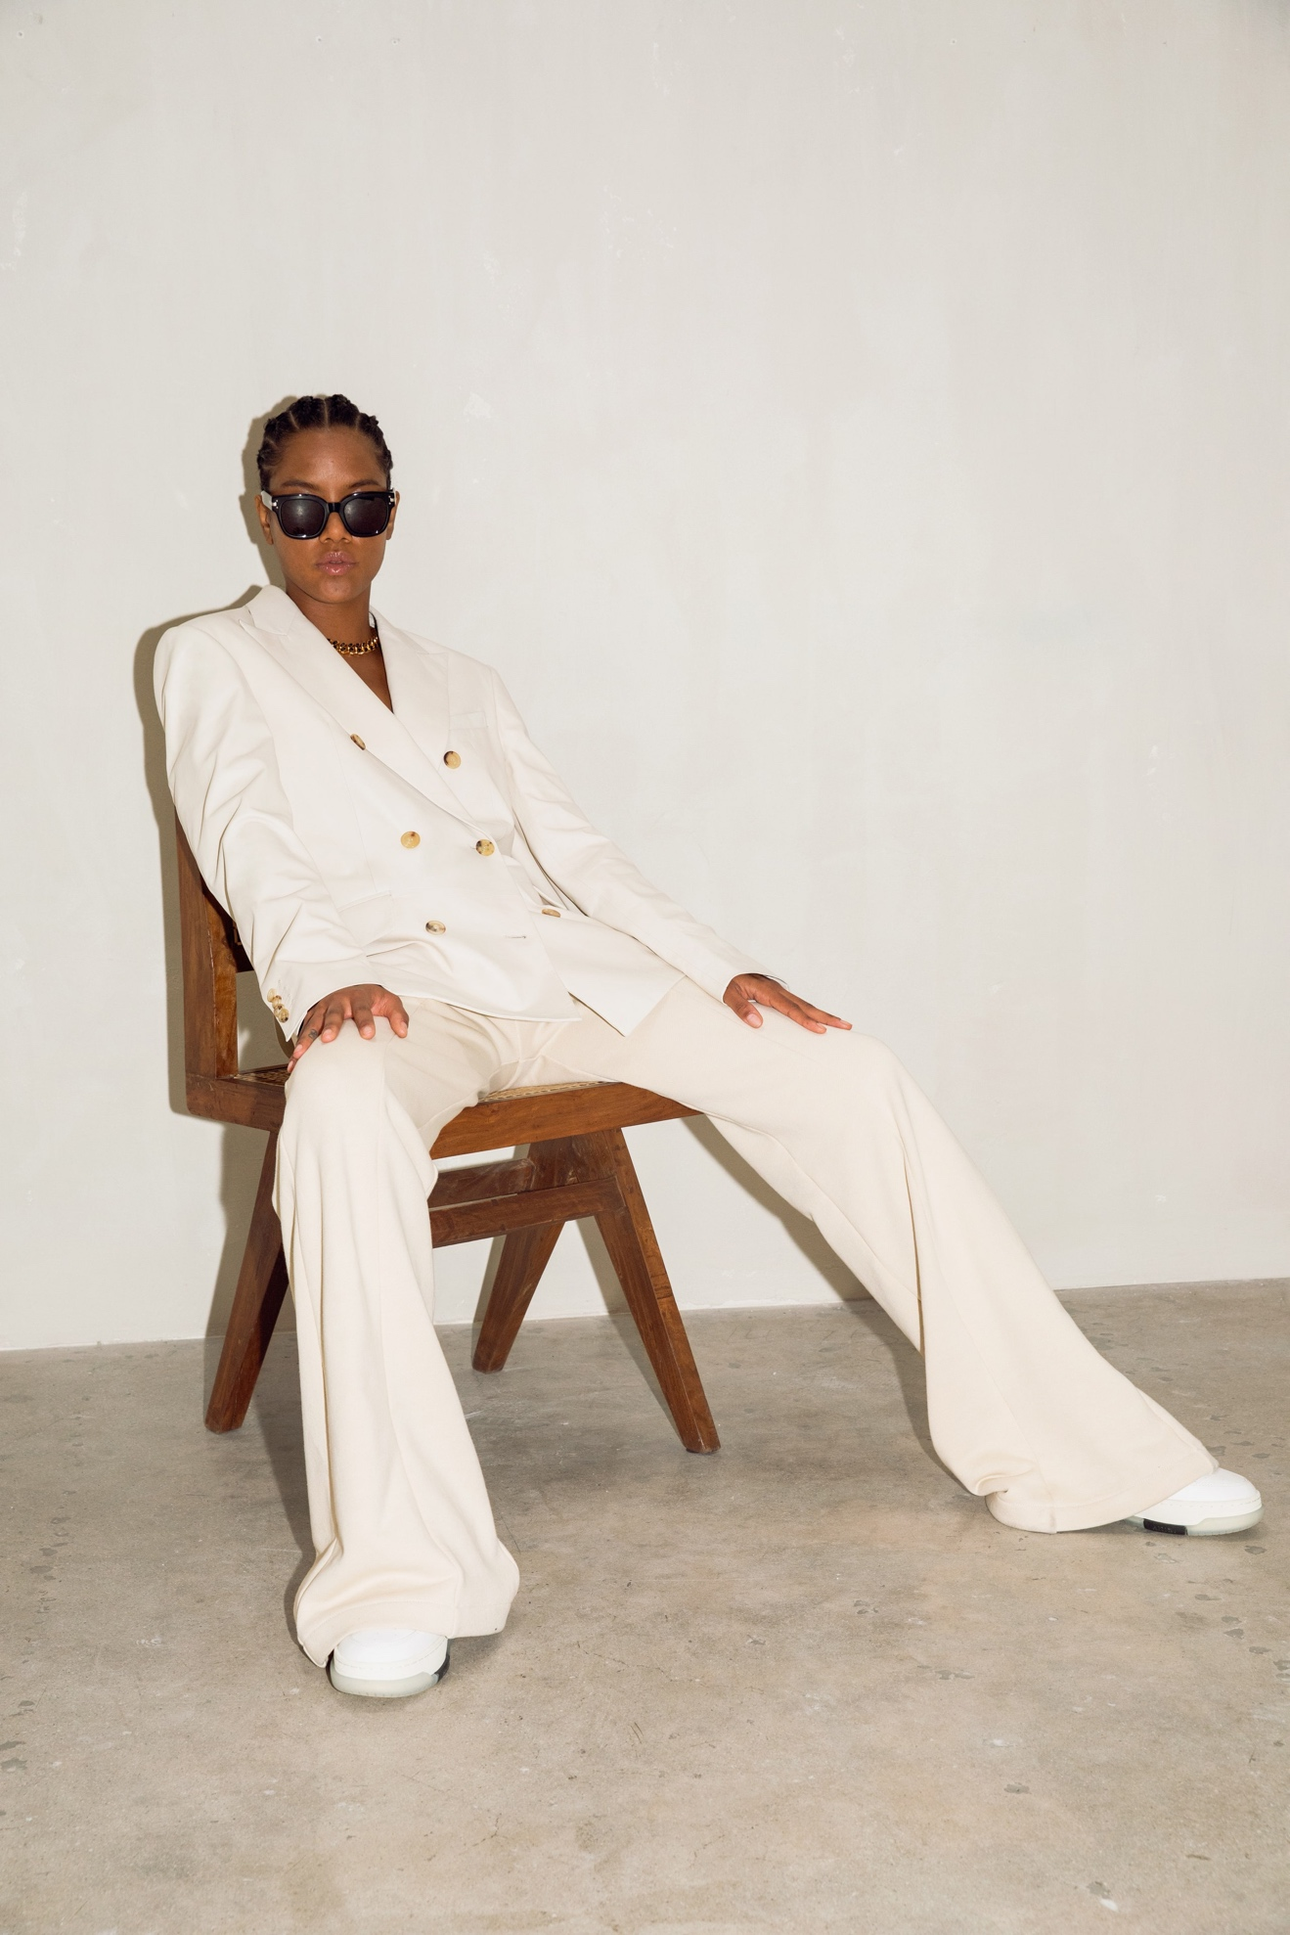Look 3](https://www.vogue.com/fashion-shows/spring-2022-ready-to-wear/amiri/slideshow/collection#3)[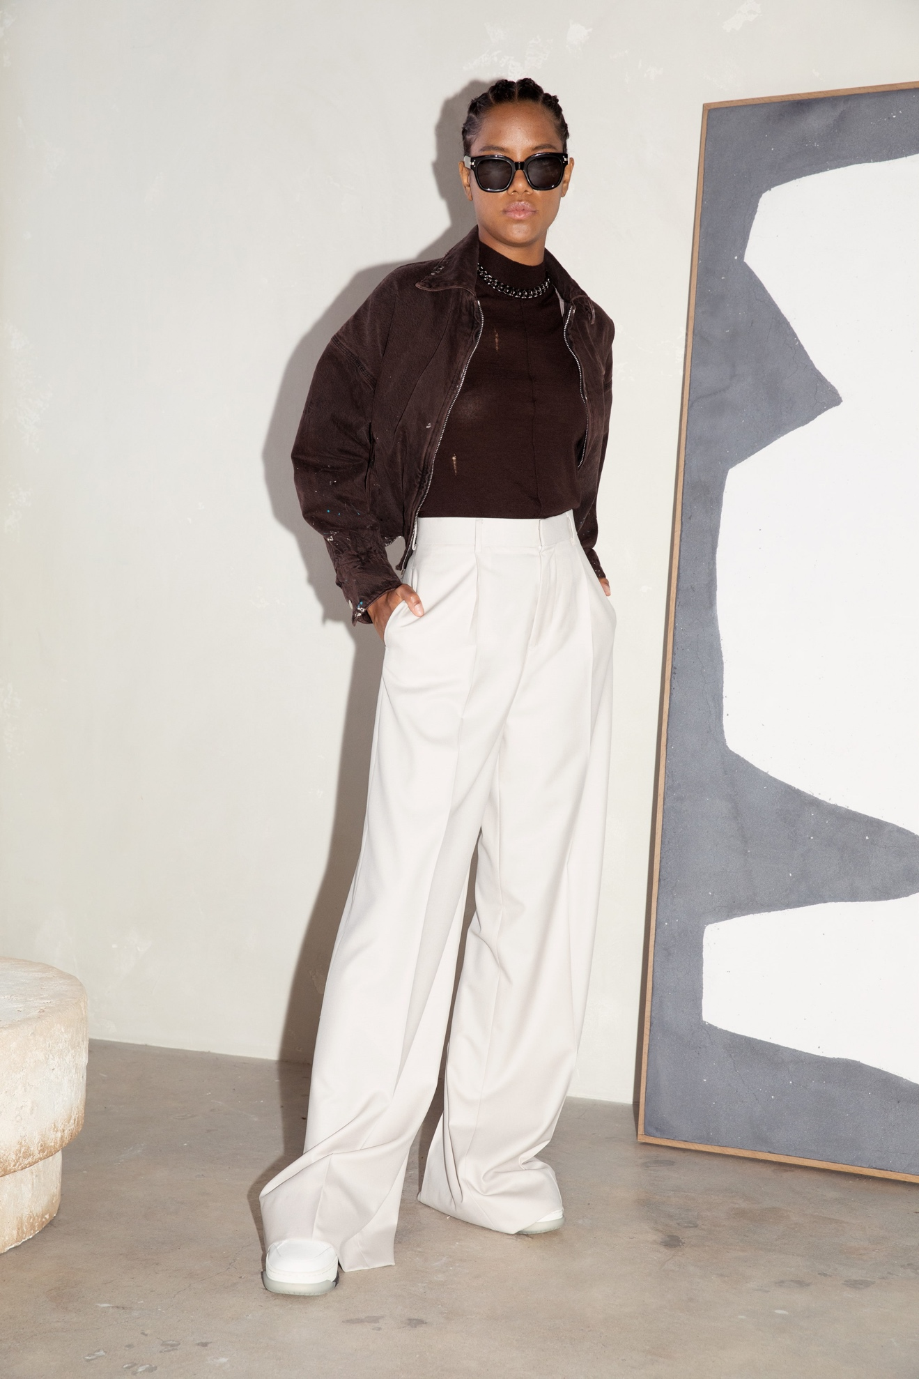Look 4](https://www.vogue.com/fashion-shows/spring-2022-ready-to-wear/amiri/slideshow/collection#4)[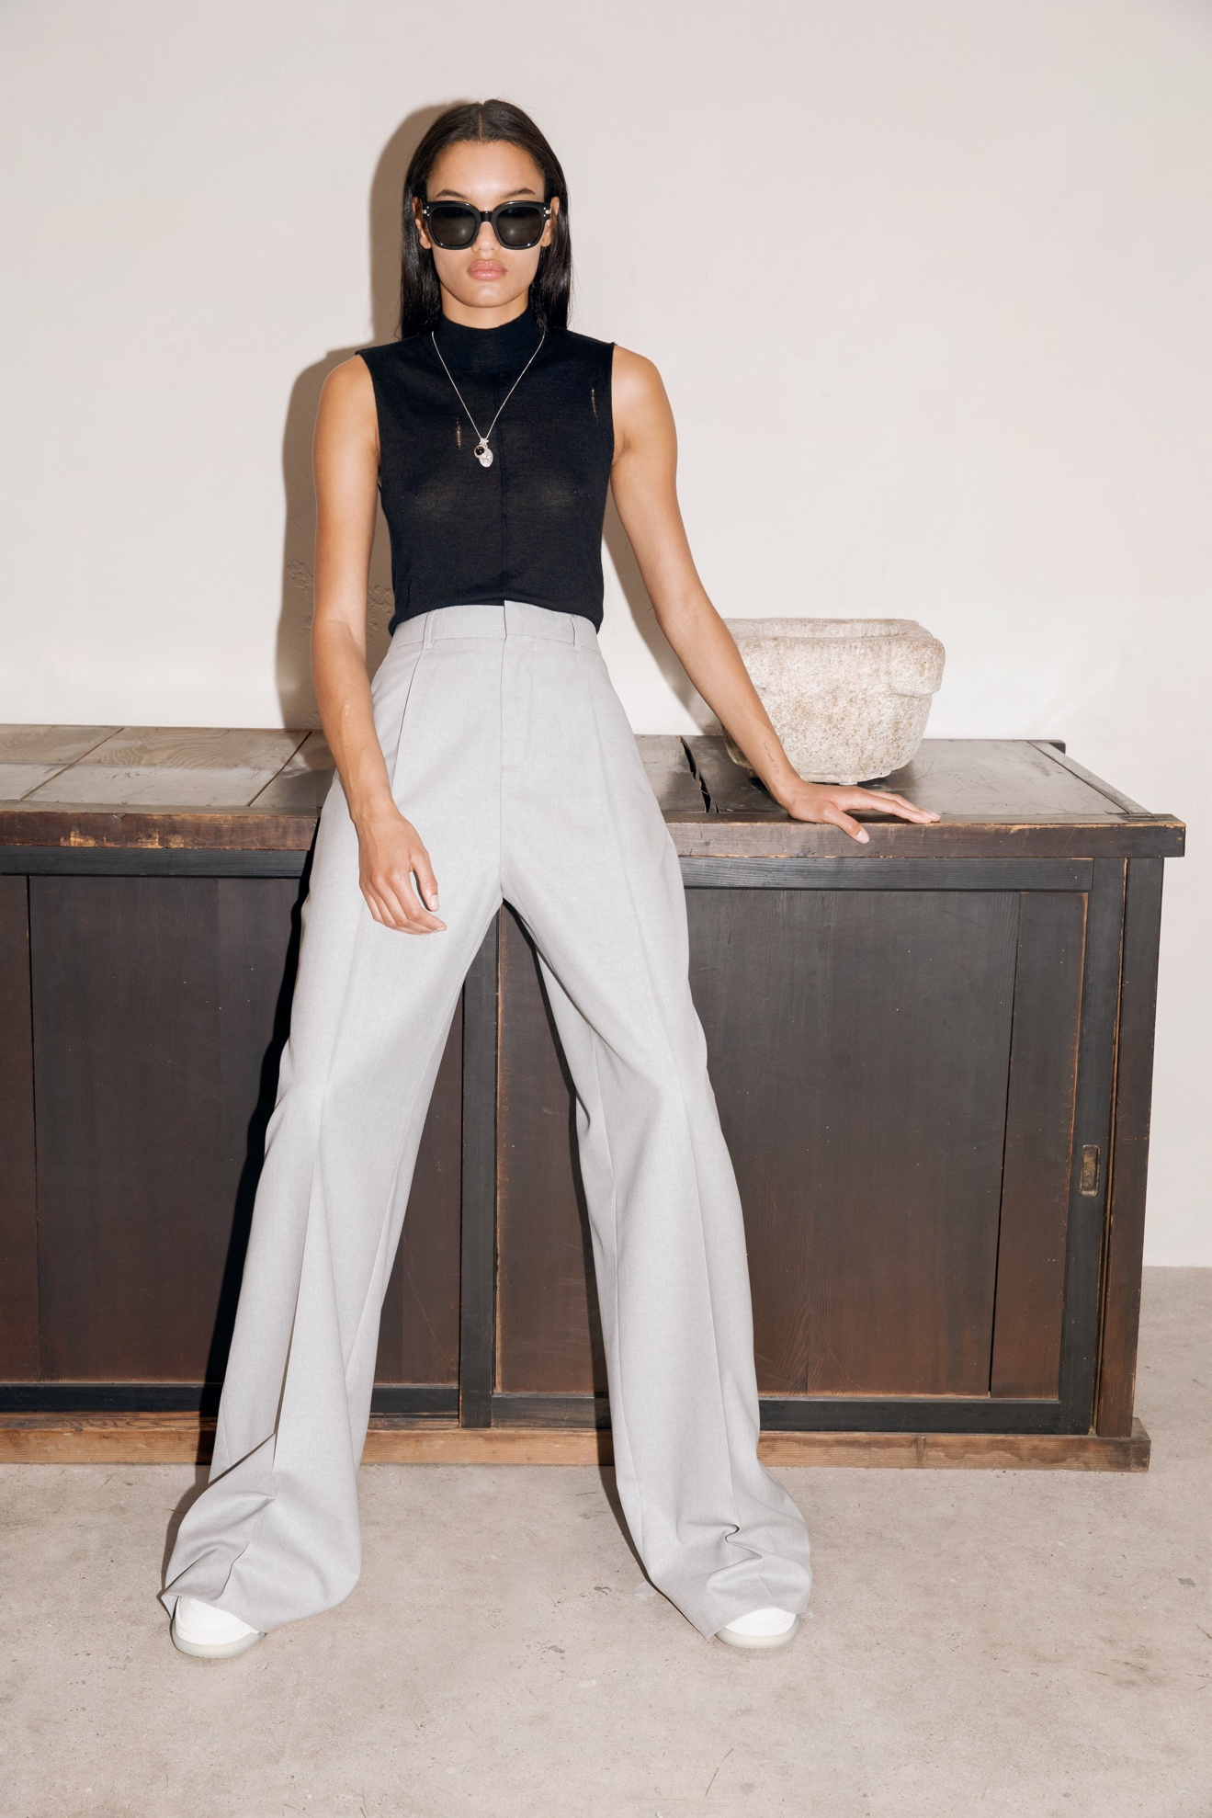Look 5](https://www.vogue.com/fashion-shows/spring-2022-ready-to-wear/amiri/slideshow/collection#5)[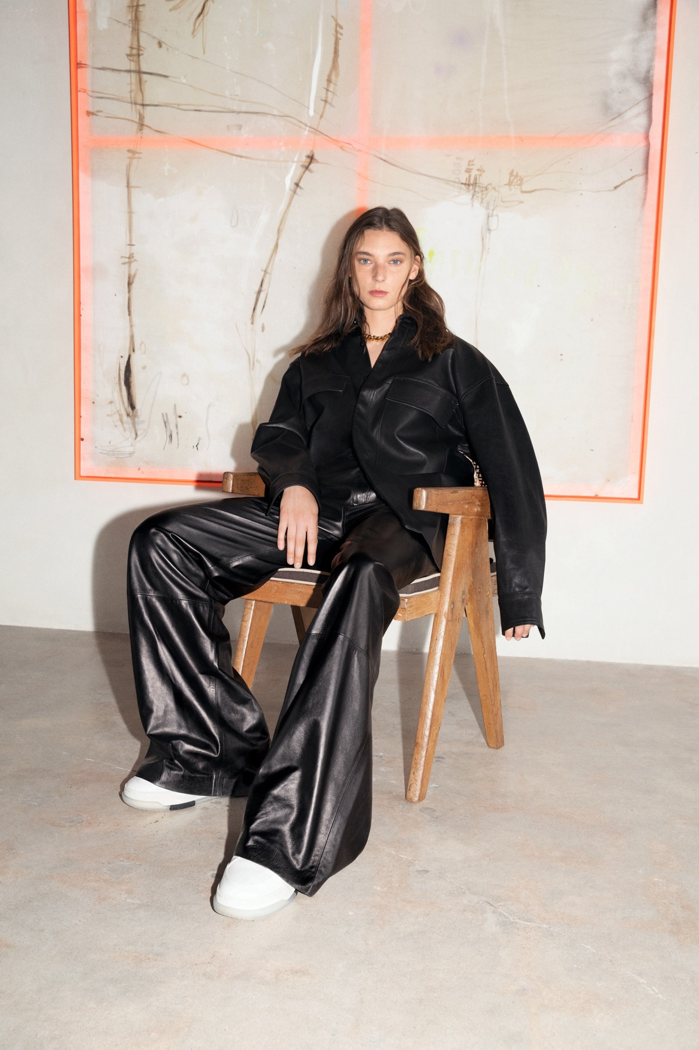Look 6](https://www.vogue.com/fashion-shows/spring-2022-ready-to-wear/amiri/slideshow/collection#6)[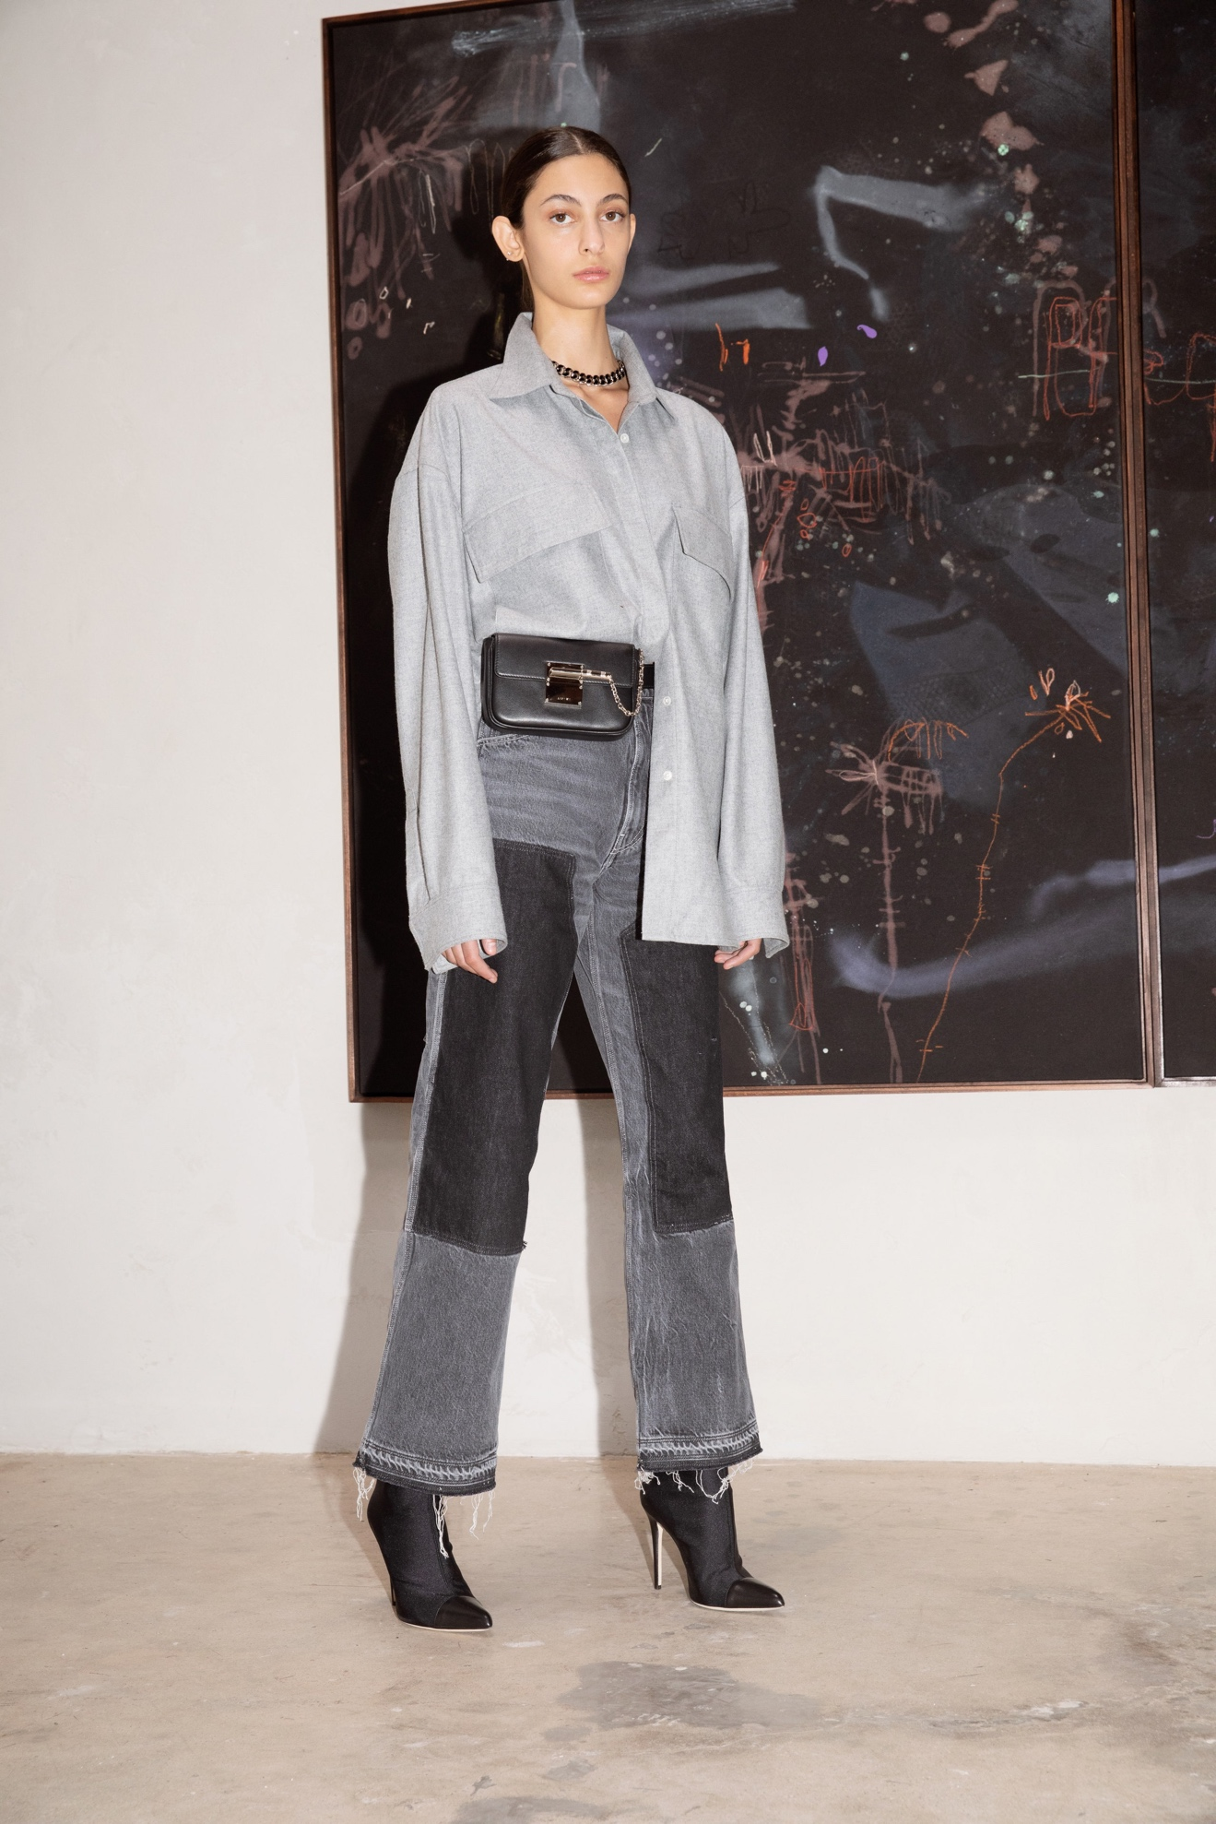Look 7](https://www.vogue.com/fashion-shows/spring-2022-ready-to-wear/amiri/slideshow/collection#7)[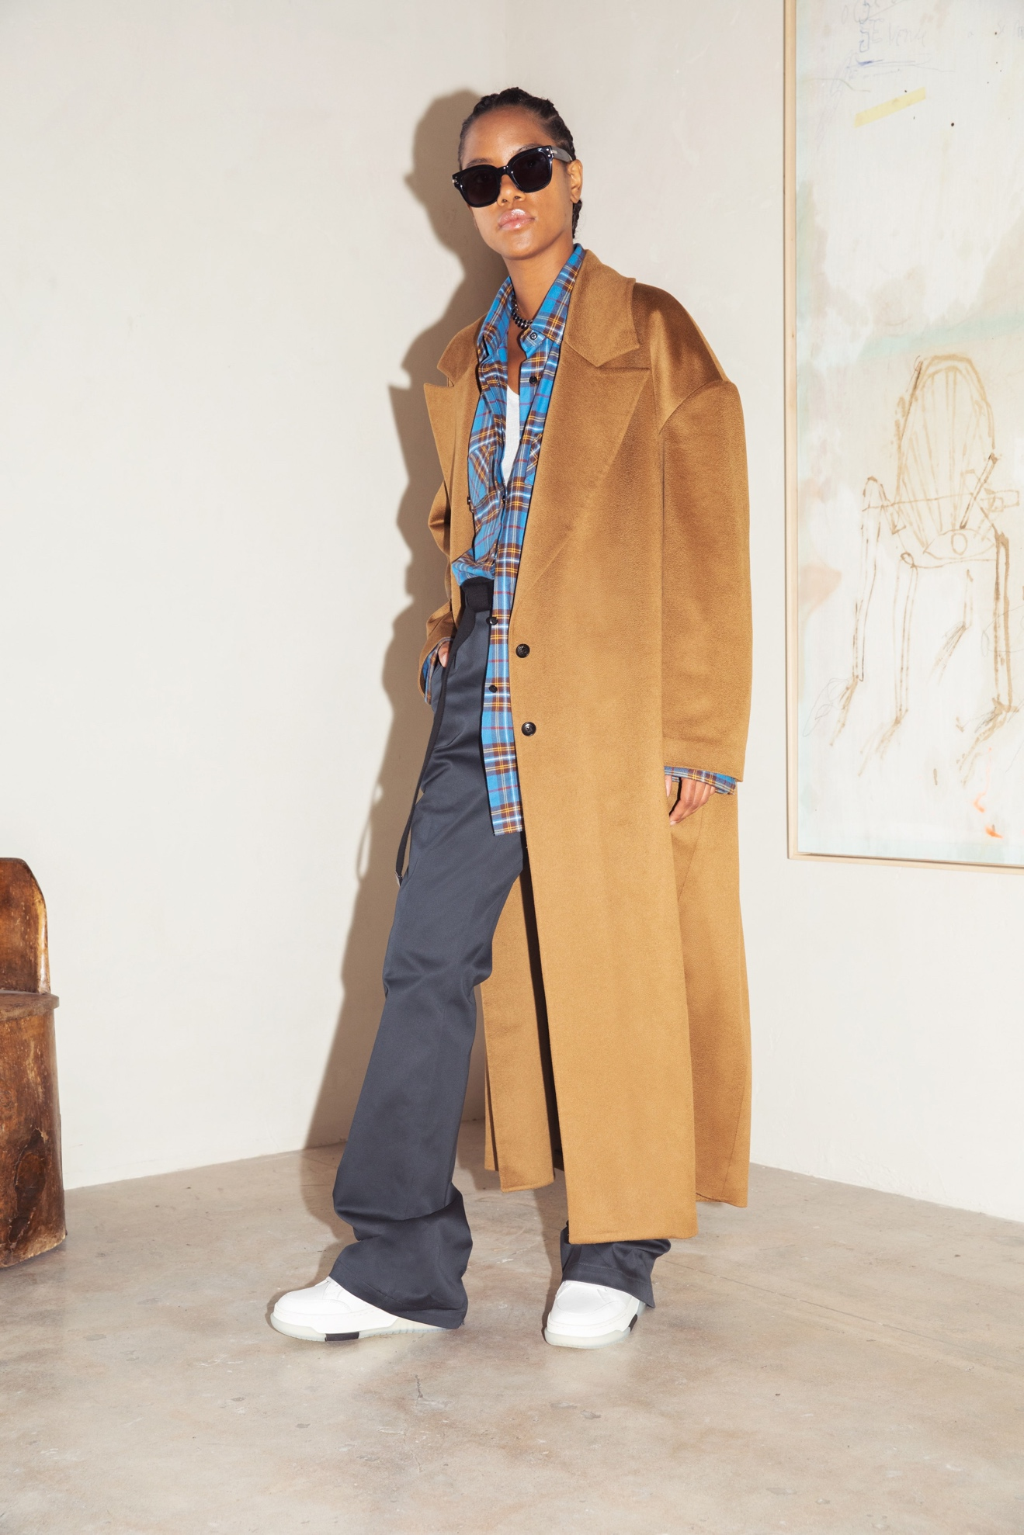Look 8](https://www.vogue.com/fashion-shows/spring-2022-ready-to-wear/amiri/slideshow/collection#8)[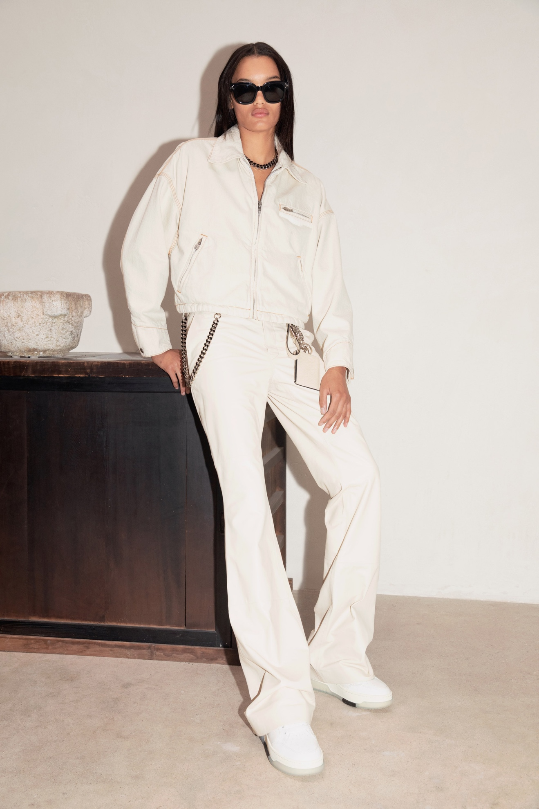Look 9](https://www.vogue.com/fashion-shows/spring-2022-ready-to-wear/amiri/slideshow/collection#9)[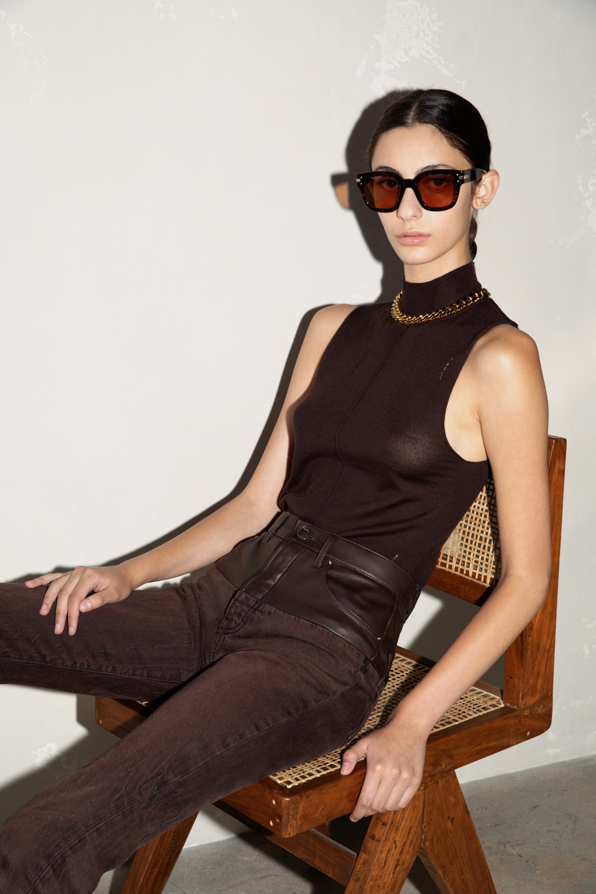Look 10](https://www.vogue.com/fashion-shows/spring-2022-ready-to-wear/amiri/slideshow/collection#10)[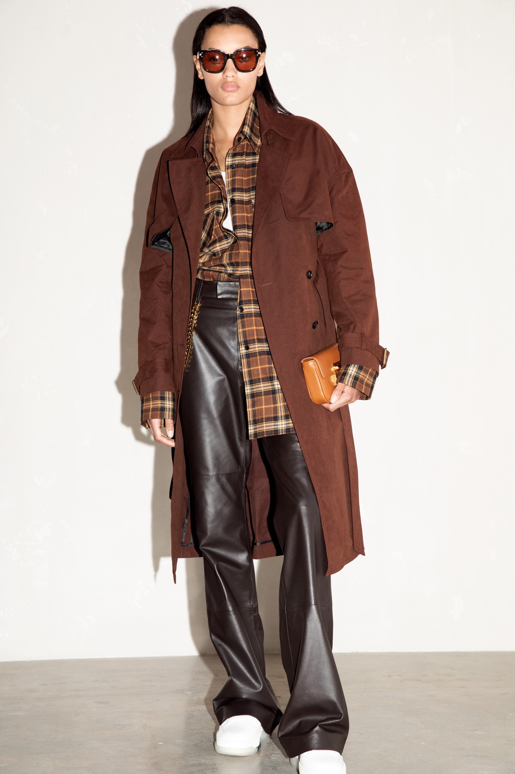Look 11](https://www.vogue.com/fashion-shows/spring-2022-ready-to-wear/amiri/slideshow/collection#11)[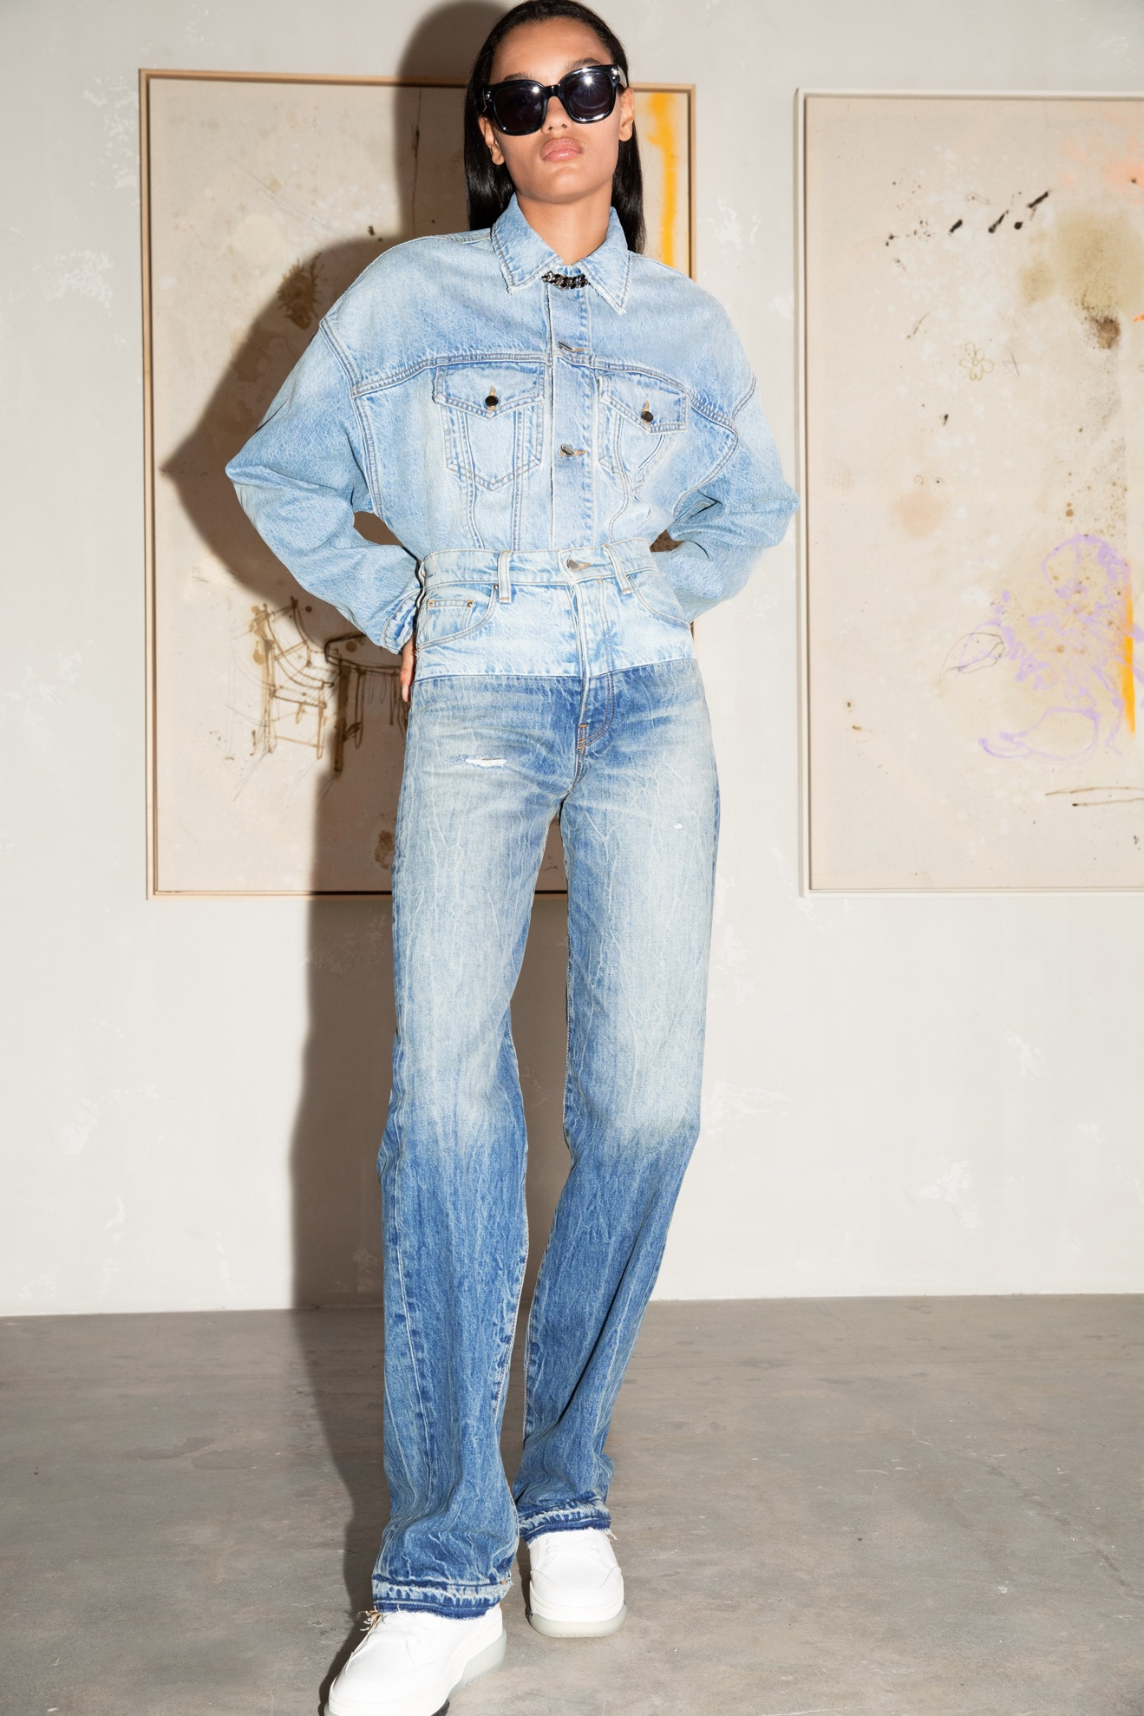Look 12](https://www.vogue.com/fashion-shows/spring-2022-ready-to-wear/amiri/slideshow/collection#12)[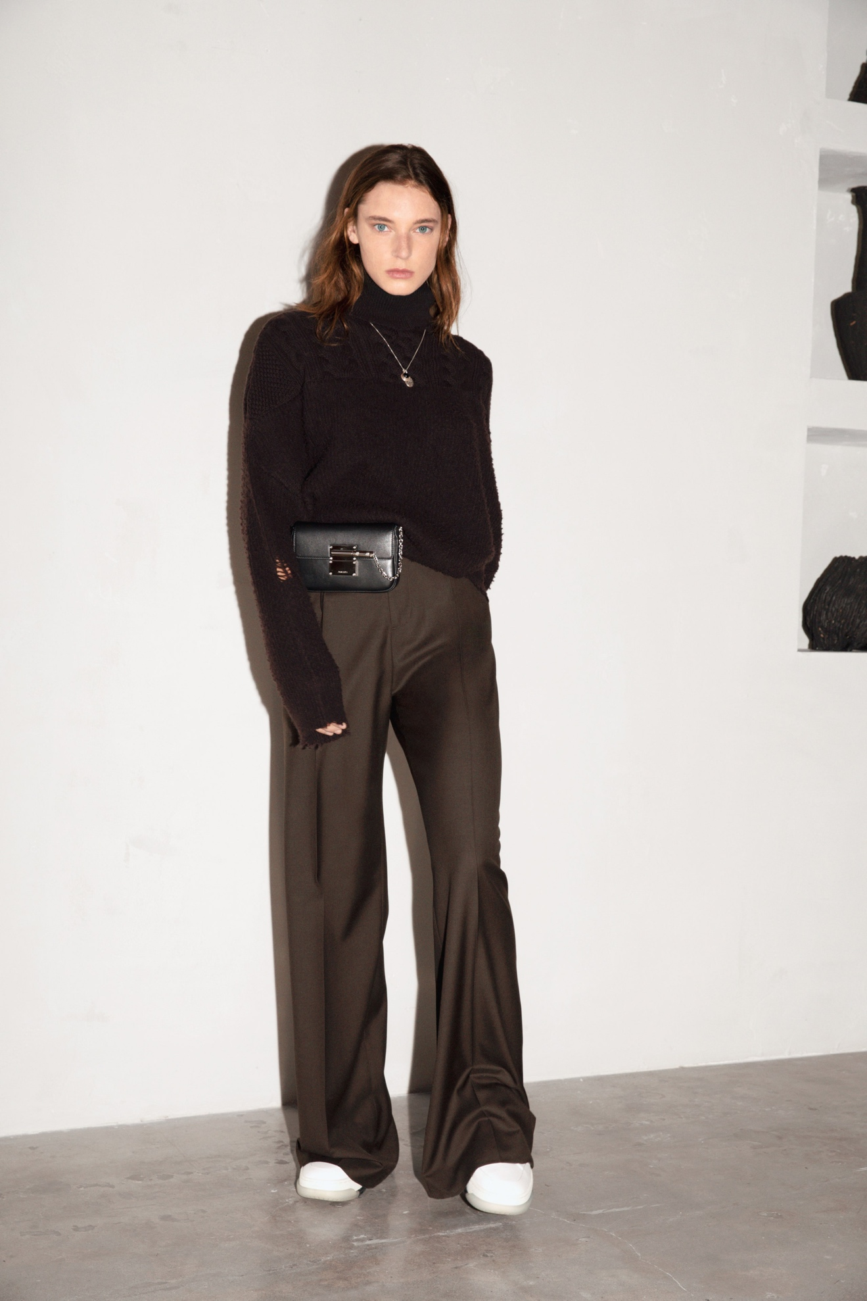Look 13](https://www.vogue.com/fashion-shows/spring-2022-ready-to-wear/amiri/slideshow/collection#13)[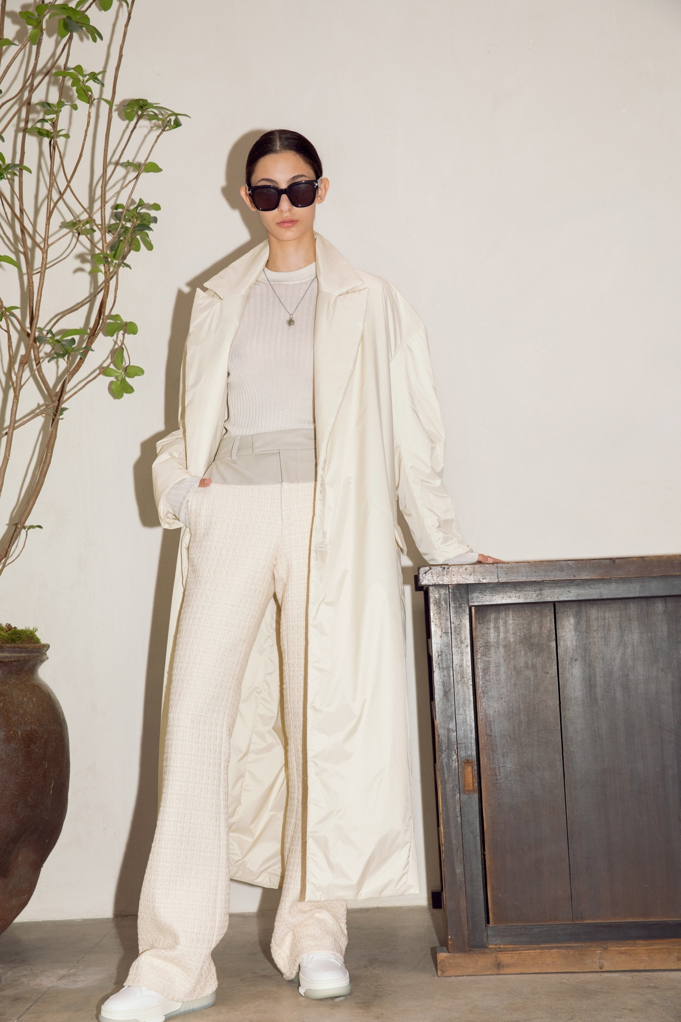Look 14](https://www.vogue.com/fashion-shows/spring-2022-ready-to-wear/amiri/slideshow/collection#14)[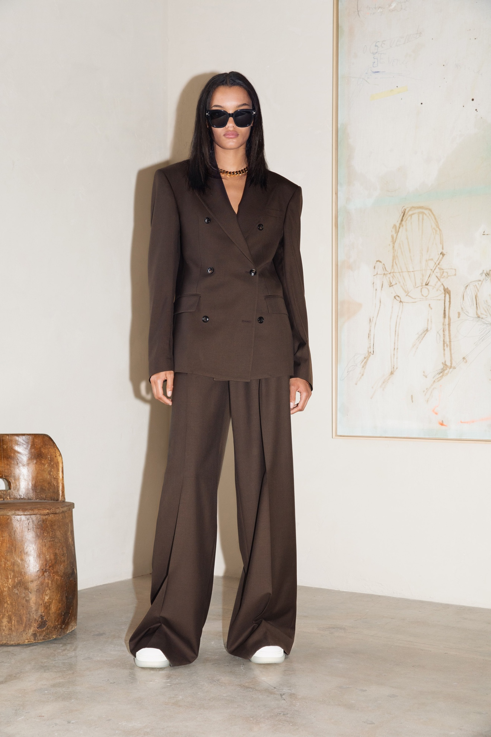Look 15](https://www.vogue.com/fashion-shows/spring-2022-ready-to-wear/amiri/slideshow/collection#15)[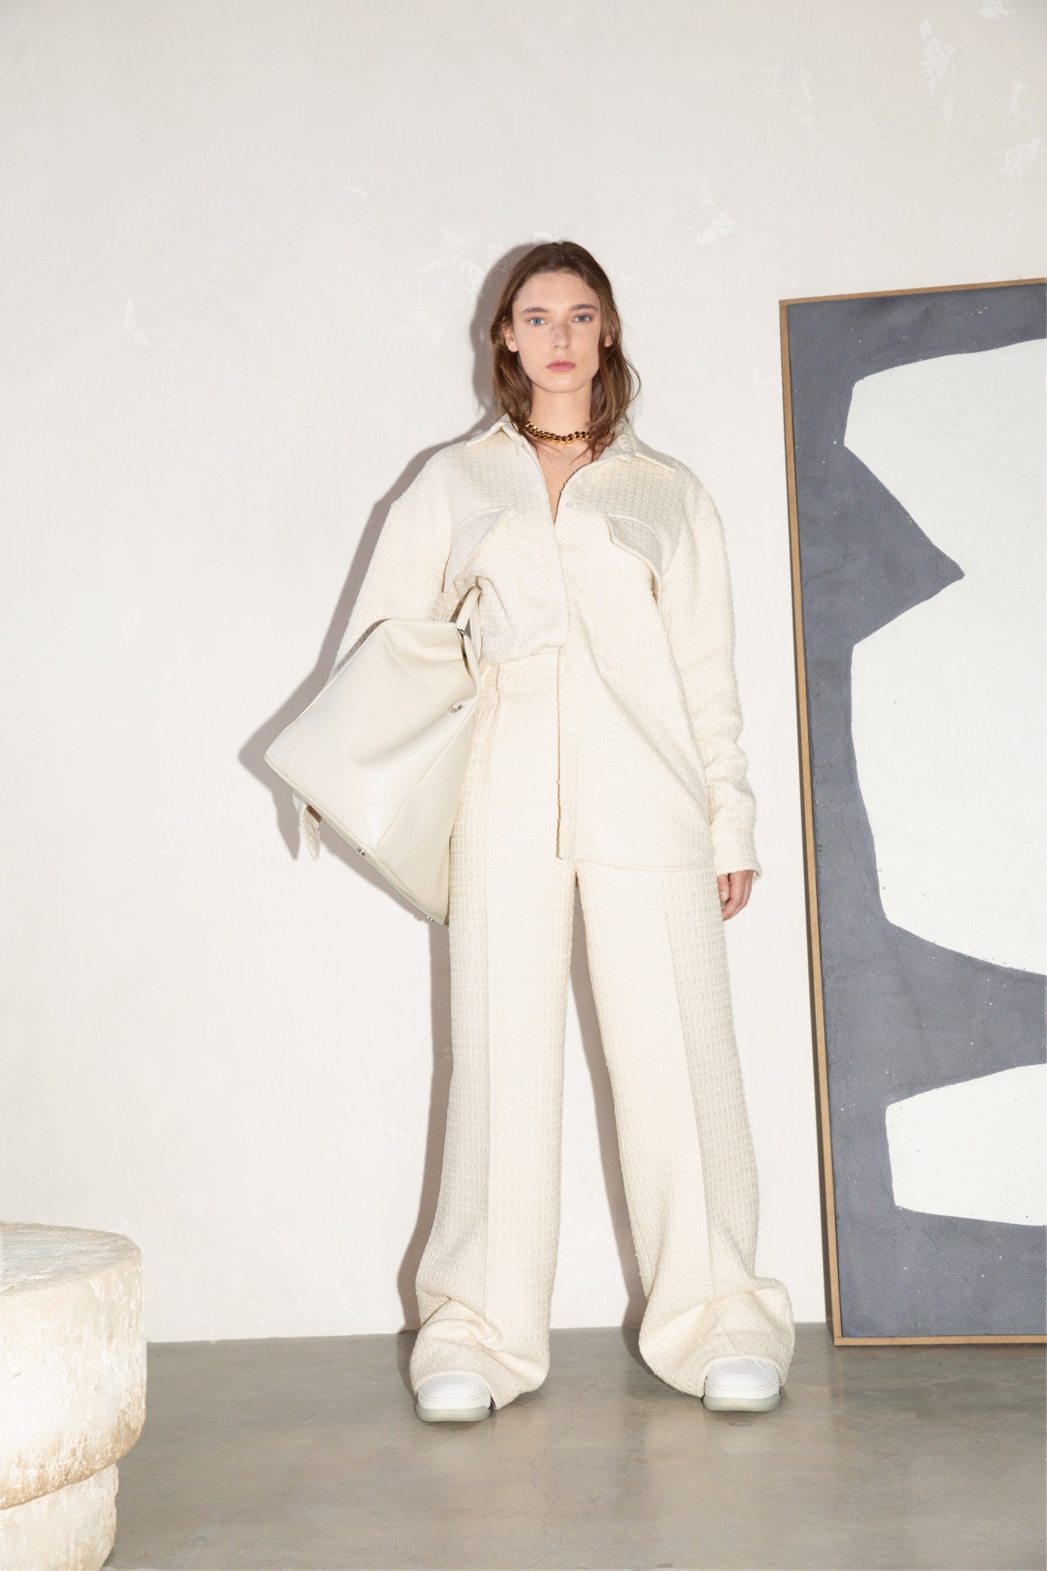Look 16](https://www.vogue.com/fashion-shows/spring-2022-ready-to-wear/amiri/slideshow/collection#16)[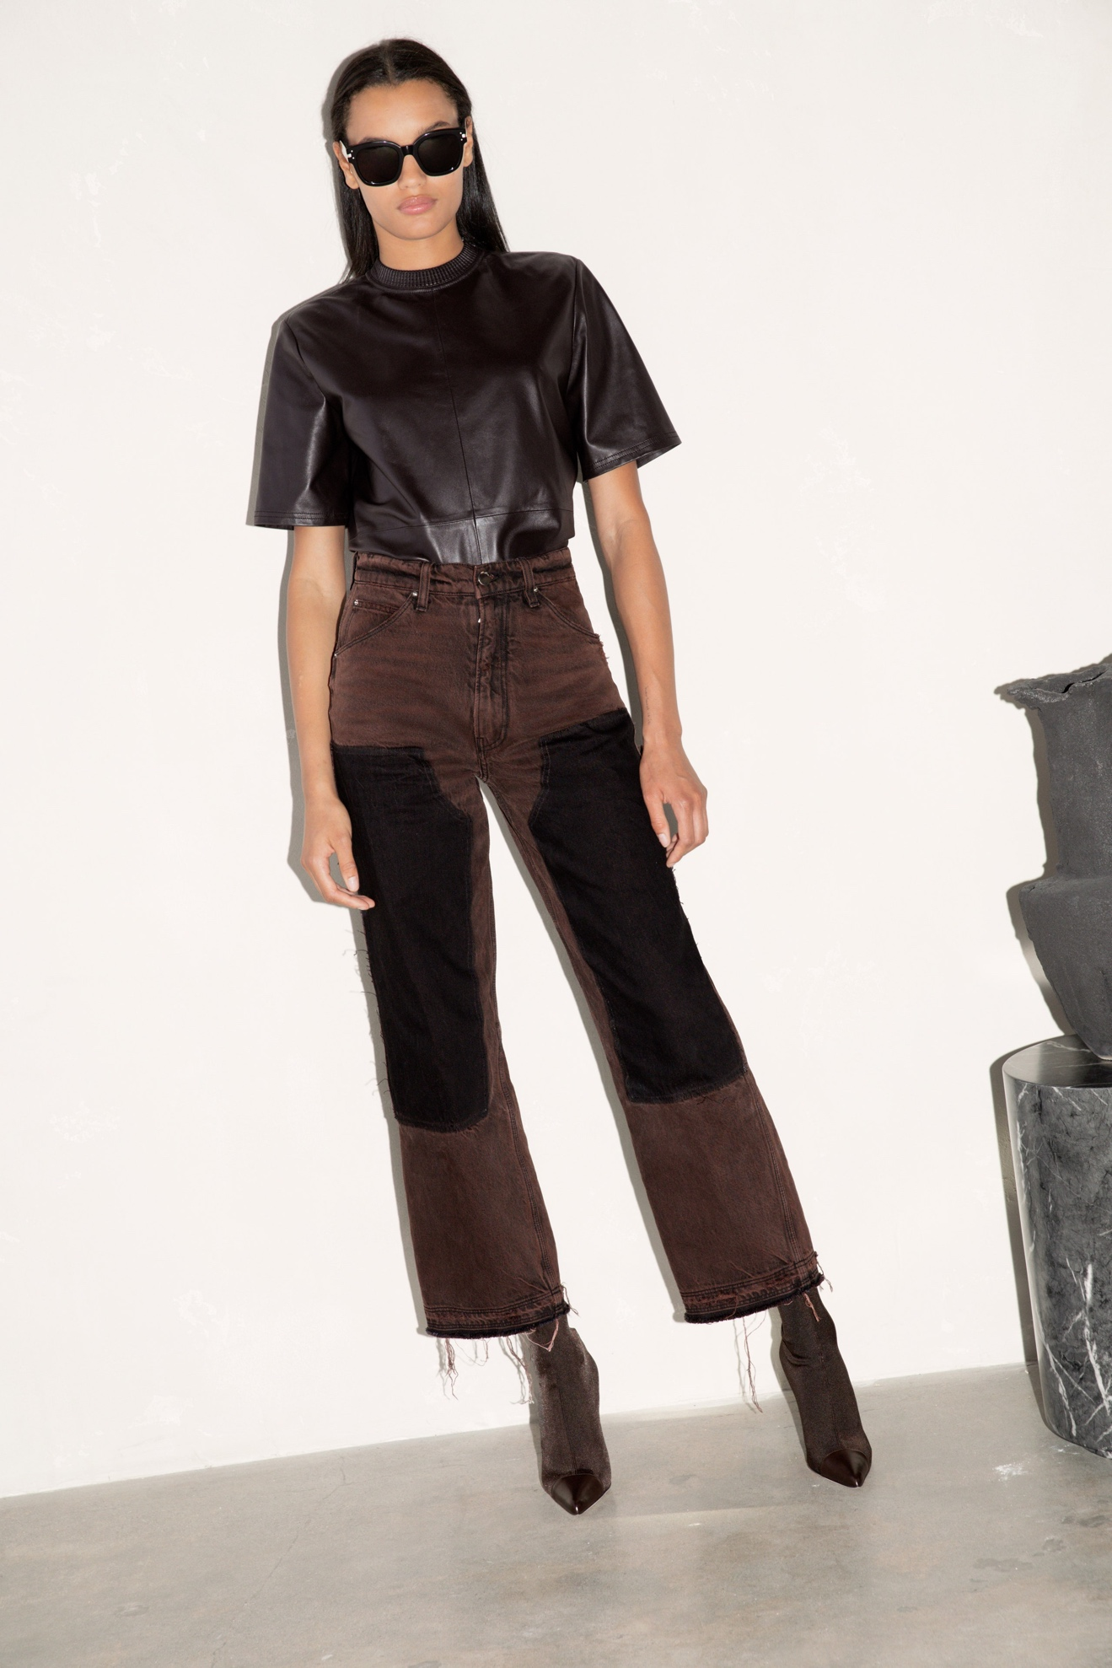Look 17](https://www.vogue.com/fashion-shows/spring-2022-ready-to-wear/amiri/slideshow/collection#17)[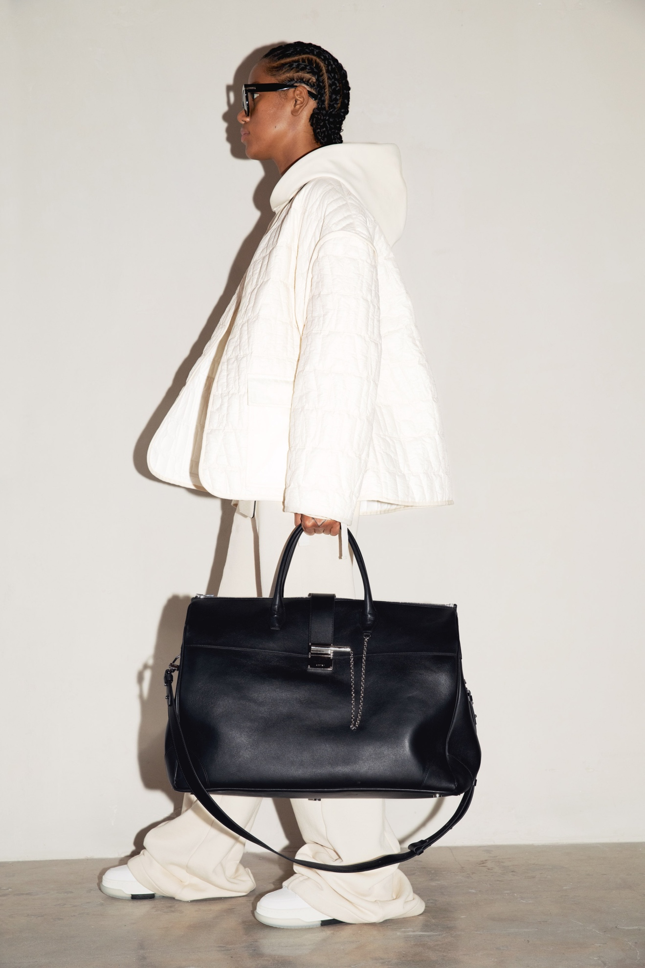Look 18](https://www.vogue.com/fashion-shows/spring-2022-ready-to-wear/amiri/slideshow/collection#18)[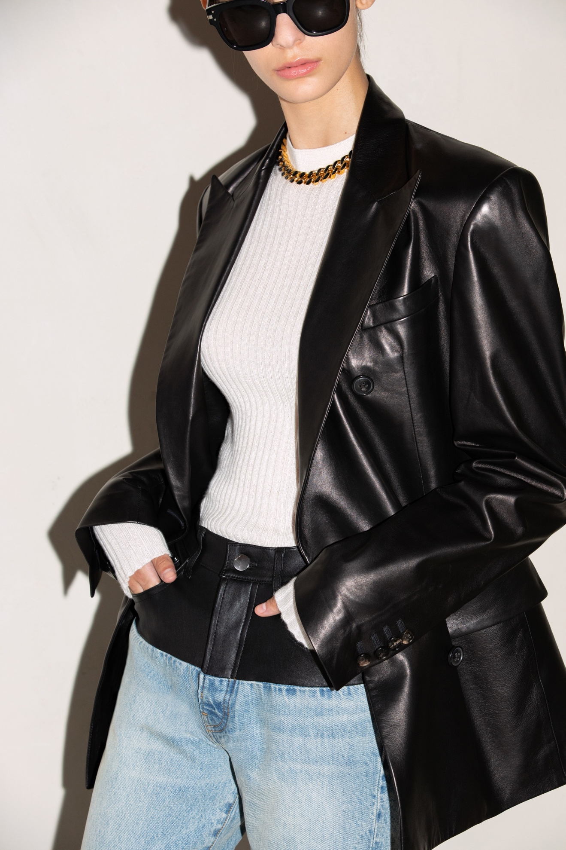Look 19](https://www.vogue.com/fashion-shows/spring-2022-ready-to-wear/amiri/slideshow/collection#19)[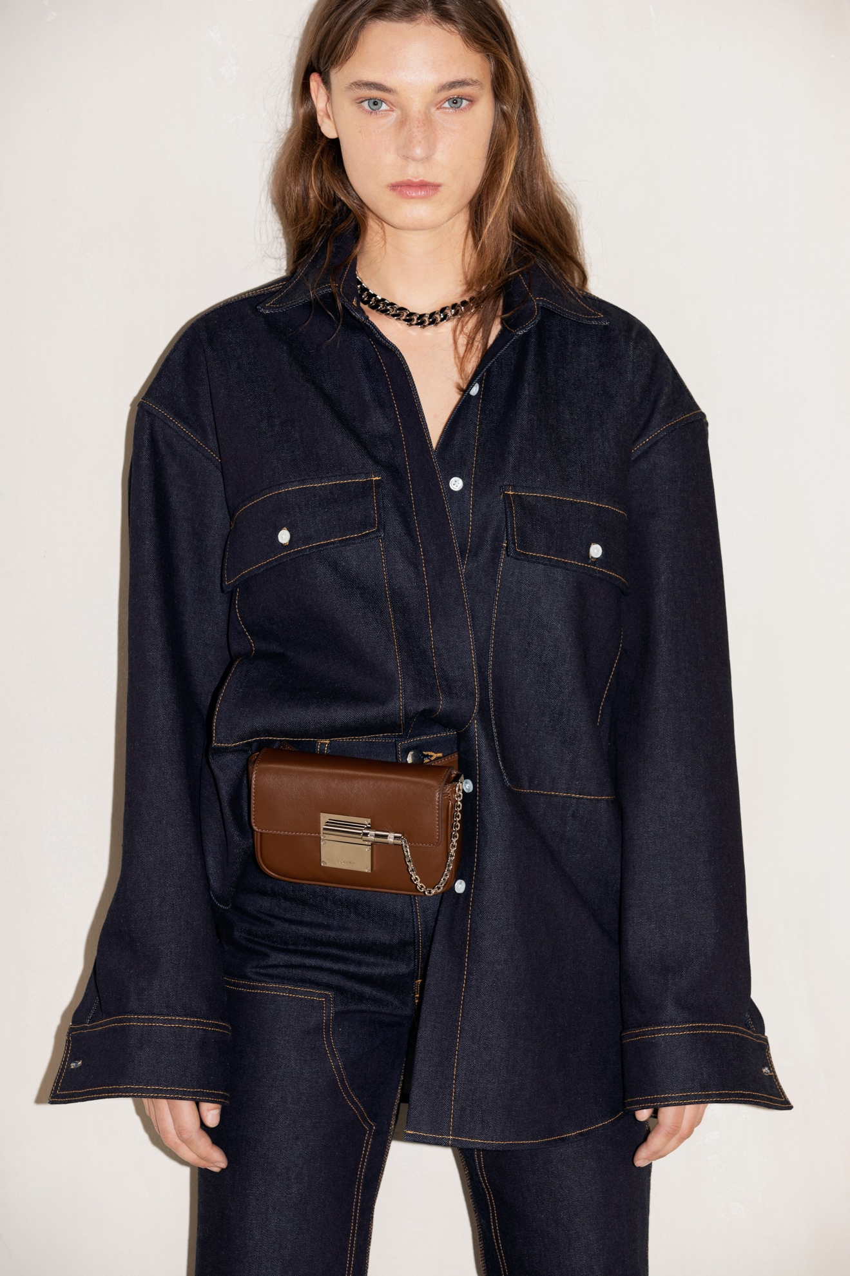Look 20](https://www.vogue.com/fashion-shows/spring-2022-ready-to-wear/amiri/slideshow/collection#20)[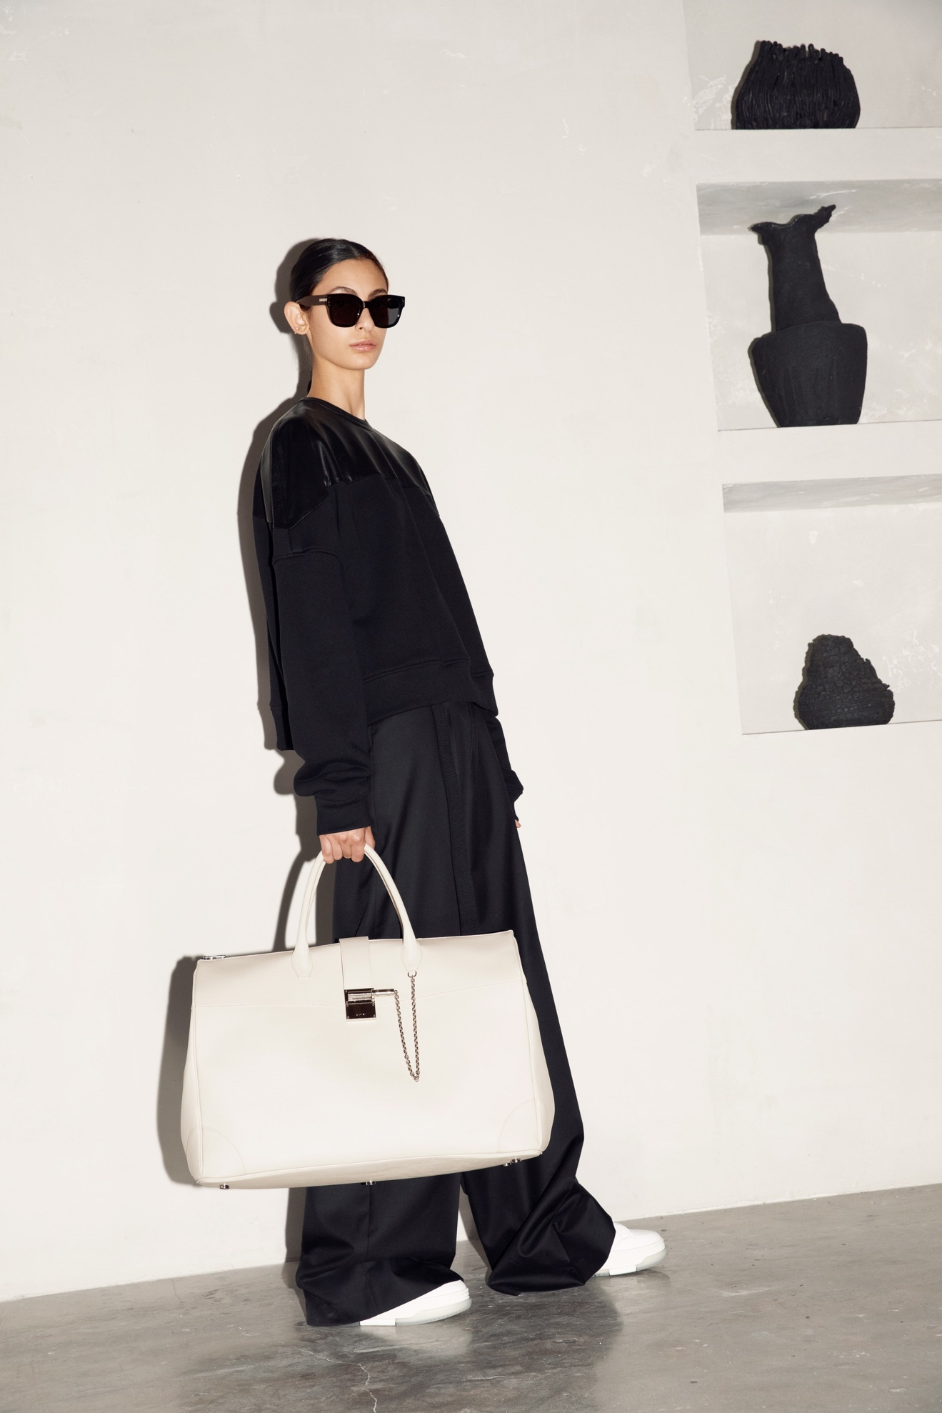Look 21](https://www.vogue.com/fashion-shows/spring-2022-ready-to-wear/amiri/slideshow/collection#21)[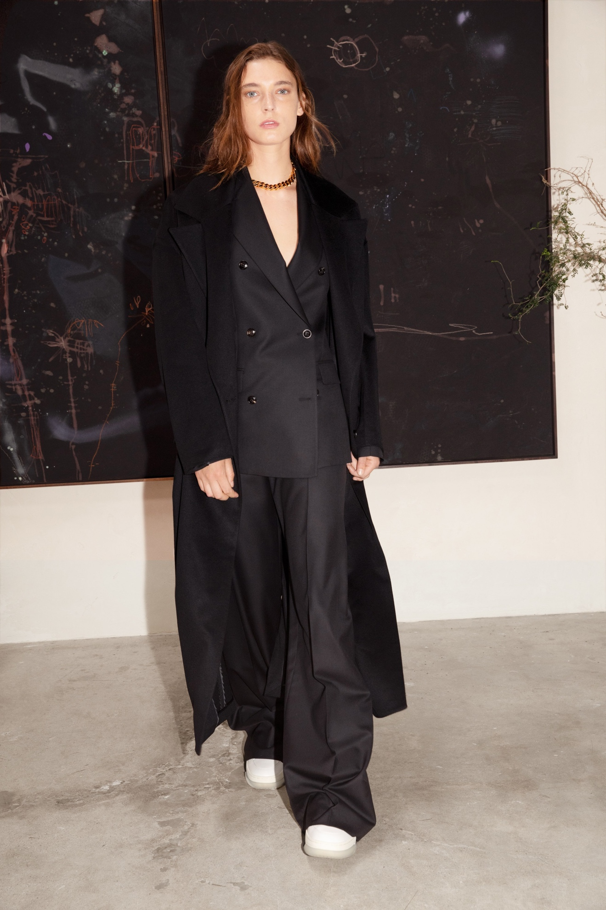Look 22](https://www.vogue.com/fashion-shows/spring-2022-ready-to-wear/amiri/slideshow/collection#22)